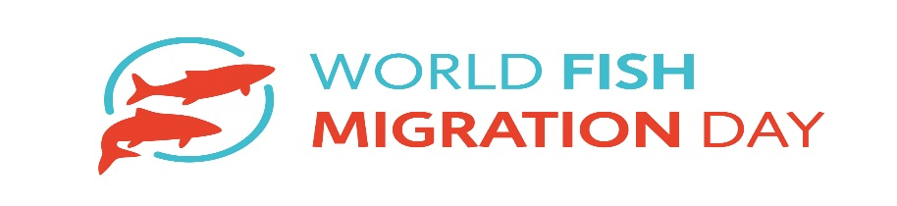 [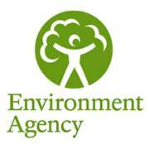](http://www.google.co.uk/url?sa=i&rct=j&q=&esrc=s&source=images&cd=&cad=rja&uact=8&ved=&url=http://redmaterials.co.uk/news/coming-april-1st-changes-hazardous-waste-consignment/&psig=AOvVaw1K6-gEkMmDlGOwj_I3sZ4_&ust=1507198082234758)

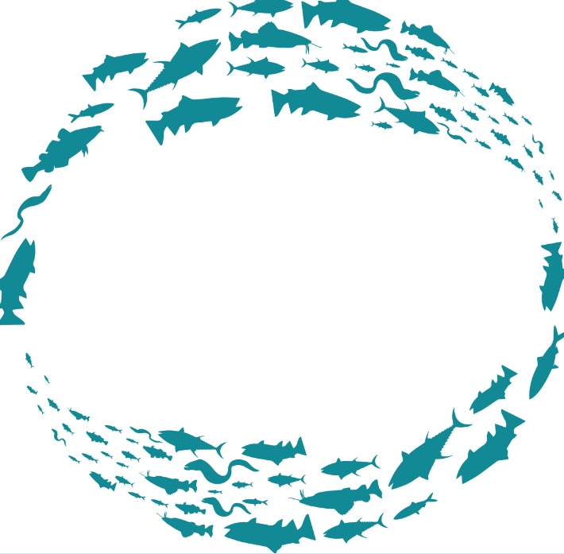

World Fish Migration day -

**25th May 2024**

**Flatford Mill, Suffolk**

Educational two day event on the life cycle and migration of the European EEL.

Run by the Environment Agency.

Live adult Eels and Elvers will be on show at the fish pass at the National Trust visitor centre for School groups and the public.

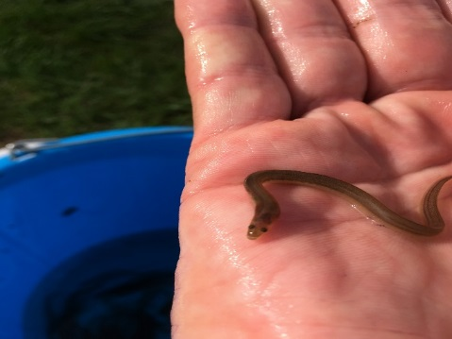 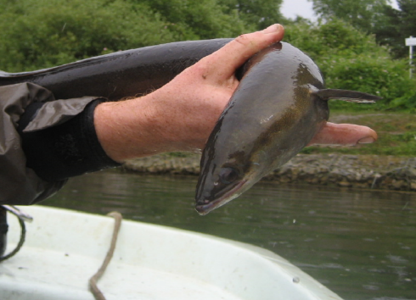

**info details:** [**ben.norrington@environment-agency.gov.uk**](mailto:ben.norrington@environment-agency.gov.uk) **worldfishmigrationday.com**